26.89: a) Using Kirchhoff’s Rules on the circuit we find:
Left loop:
Right loop:
Currents: 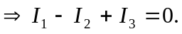
Solving for the three currents we have:
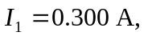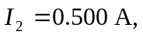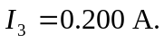
b) Leaving only the 92-V battery in the circuit:
Left loop: 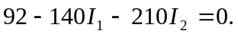
Right loop: 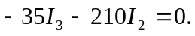
Currents: 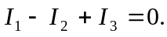

Solving for the three currents:
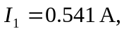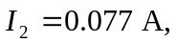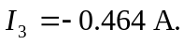

c) Leaving only the 57-V battery in the circuit:
Left loop: 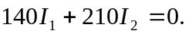
Right loop: 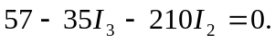
Currents:
Solving for the three currents:
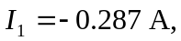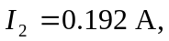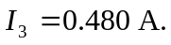
d) Leaving only the 55-V battery in the circuit:
Left loop: 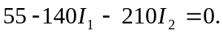
Right loop: 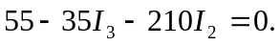
Currents: 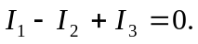
Solving for the three currents:
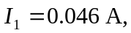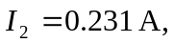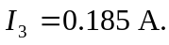
e) If we sum the currents from the previous three parts we find:
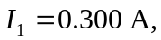 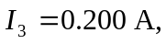 just as in part (a).
f) Changing the 57-V battery for an 80-V battery just affects the calculation in part (c). It changes to:
Left loop: 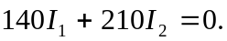
Right loop: 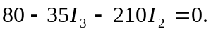
Currents:
Solving for the three currents:
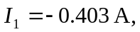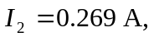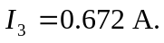
So the total current for the full circuit is the sum of (b), (d) and (f) above:
